REPORT

Laboratory work No. 4
Course: Cryptography and Security
Theme: Block Cipher. DES

Author: Corneliu Catlabuga
FAF-213

Checked by: univ. assist.
Cătălin Mîțu

Objective:
Understand and implement an element of the DES algorithm.
Task:
Get Sj(Bj) for a given 48-bit block from i-th round of the DES algorithm for the XOR permutation K_{i}+E_{i}(B_{i-1}).
Theoretical considerations:
The Data Encryption Standard (DES) is a symmetric-key block cipher algorithm used for encrypting and decrypting data. It operates on 64-bit blocks of data and uses a 56-bit key to control the encryption process. DES employs a series of 16 rounds of substitution, permutation, and XOR operations to transform the plaintext into ciphertext.

Implementation, practical results:
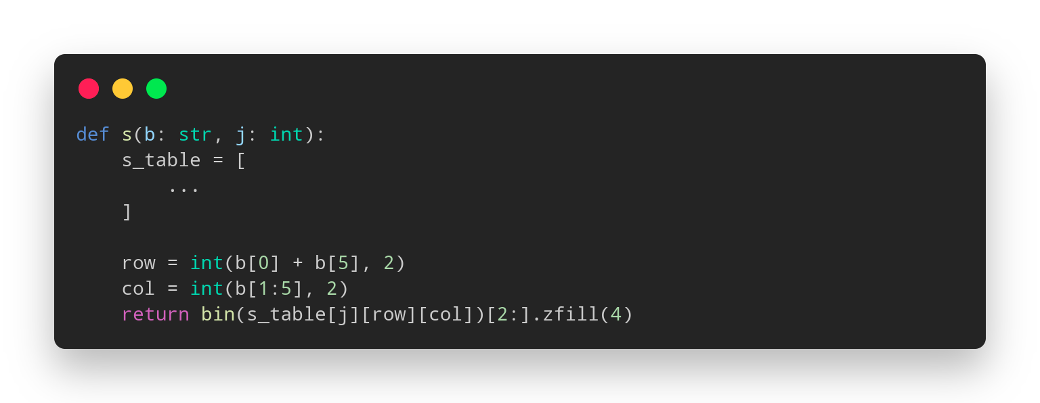
Figure 1: S_{j}(B_{j-1}) function

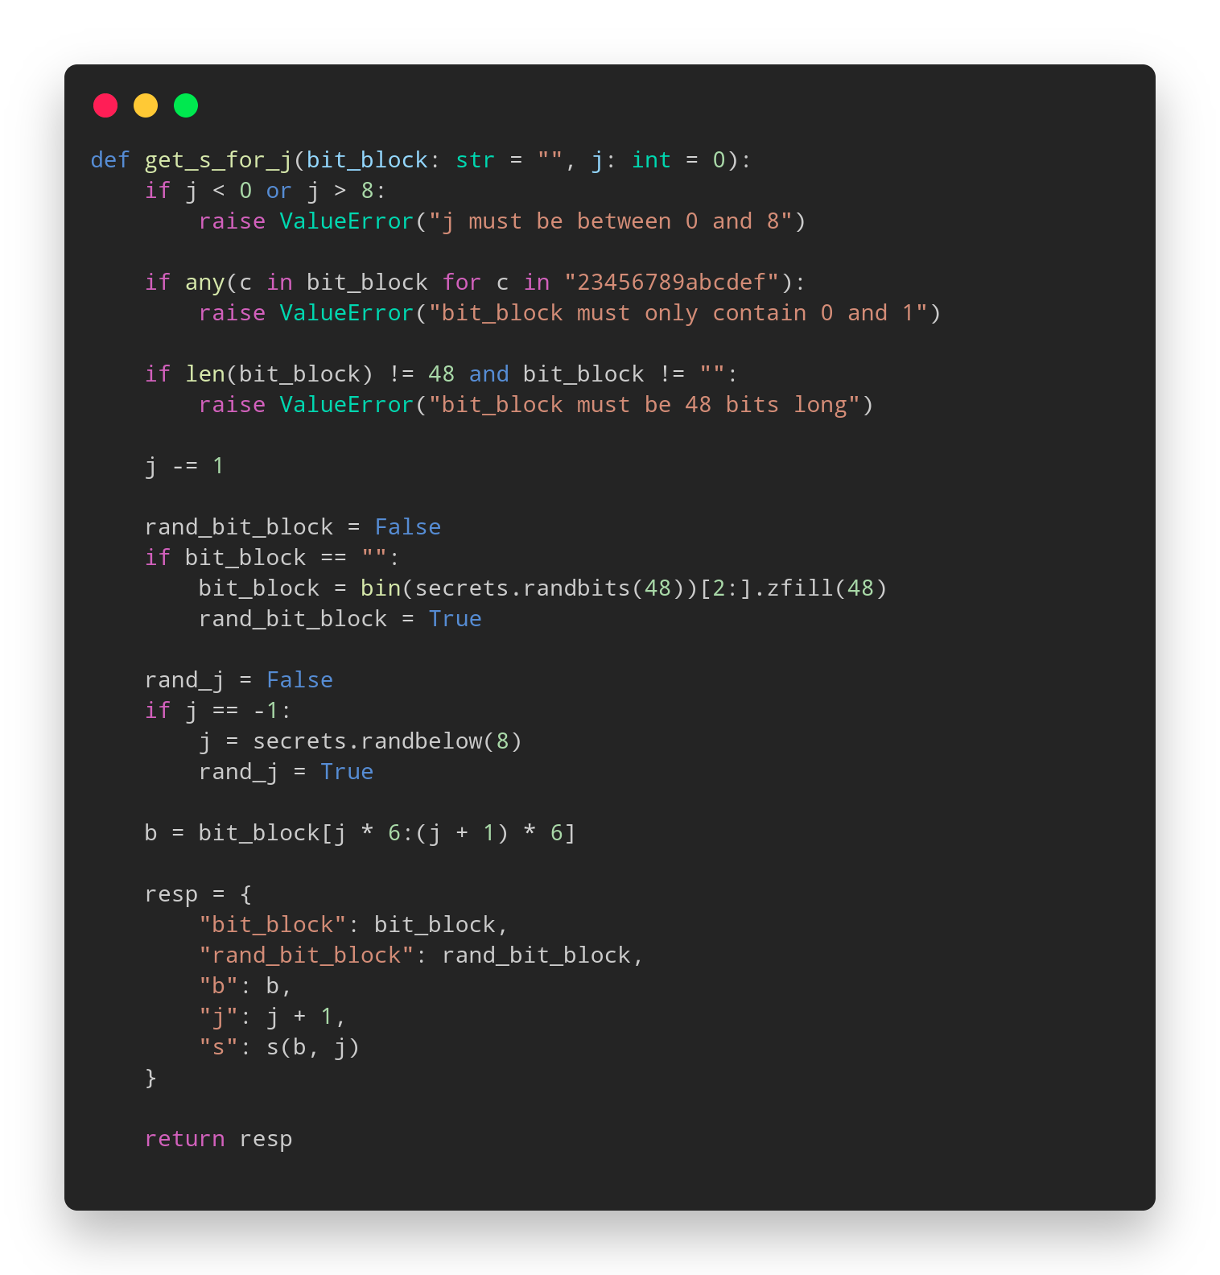
Figure 2: Final function for S_{j}(B_{j-1})

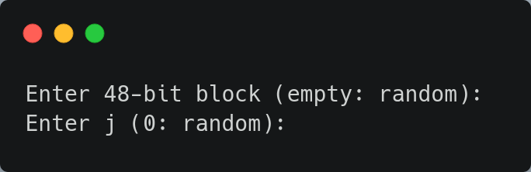
Figure 3: Input prompt

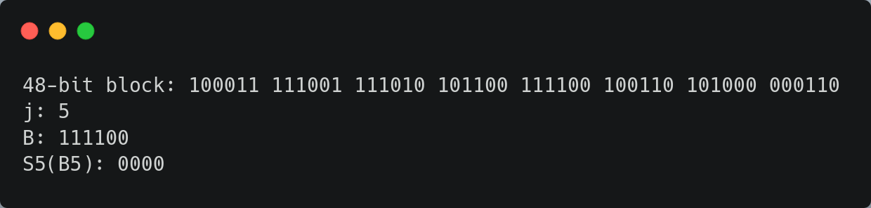
Figure 4: Output
Conclusions:
In the Data Encryption Standard (DES) algorithm, computing S_{j}(B_{j}) for the output of
K_{i}+E(B_{i-1}) plays a crucial role in the substitution (S-box) layer of the encryption process. This step involves replacing blocks of bits with different values based on predefined substitution tables, which adds a non-linear and confounding element to the algorithm.
References:
1. Github repo: https://github.com/muffindud/CS_Lab/tree/lab4/lab4

